RIP for 4 routers…

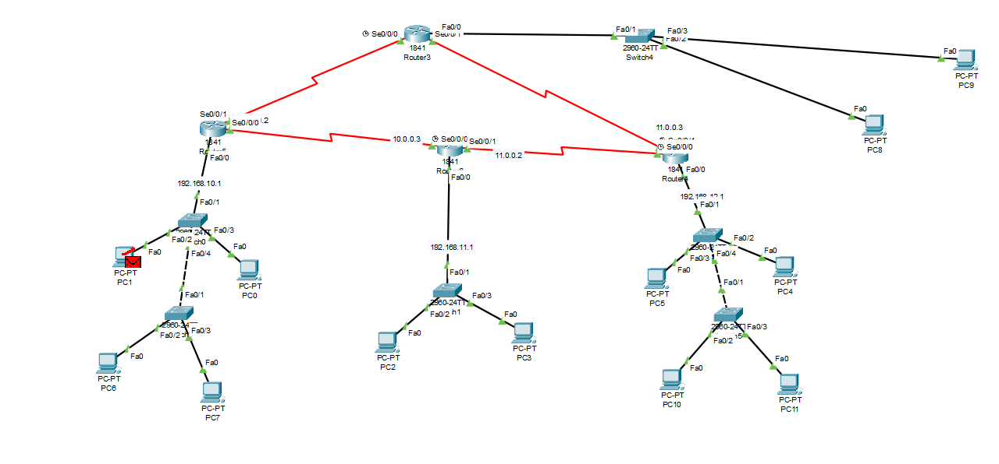

Router 1 Configuration

|  |
| --- |
| Router>en  Router#conf t  Enter configuration commands, one per line. End with CNTL/Z.  Router(config)#int fa0/0  Router(config-if)#ip address 192.168.10.1 255.255.255.0  Router(config-if)#no shutdown  Router(config-if)#int serial 0/0/0  Router(config-if)#ip address 10.0.0.1 255.255.255.252  Router(config-if)#no shutdown  Router(config-if)#int serial 0/0/1  Router(config-if)#ip address 10.0.1.1 255.255.255.252  Router(config-if)#no shutdown  Router(config-if)#router rip  Router(config-router)#version 2  Router(config-router)#network 192.168.10.0  Router(config-router)#network 10.0.0.0  Router(config-router)#network 10.0.1.0  Router(config-router)#exit  Router(config)#exit  Router#wr  Building configuration...  [OK]  Router# |

Router 2 cli

|  |
| --- |
| Router>en  Router#conf t  Enter configuration commands, one per line. End with CNTL/Z.  Router(config)#int fa0/0  Router(config-if)#ip address 192.168.11.1 255.255.255.0  Router(config-if)#no shutdown  Router(config-if)#int serial 0/0/0  Router(config-if)#ip address 10.0.0.2 255.255.255.252  Router(config-if)#no shutdown  Router(config-if)#int serial 0/0/1  Router(config-if)#ip address 10.0.2.1 255.255.255.252  Router(config-if)#no shutdown  Router(config-if)#router rip  Router(config-router)#version 2  Router(config-router)#network 192.168.11.0  Router(config-router)#network 10.0.0.0  Router(config-router)#network 10.0.2.0  Router(config-router)#exit  Router(config)#exit  Router#wr  Building configuration...  [OK]  Router# |

Router 3 cli

|  |
| --- |
| Router>en  Router#conf t  Enter configuration commands, one per line. End with CNTL/Z.  Router(config)#int fa0/0  Router(config-if)#ip address 192.168.12.1 255.255.255.0  Router(config-if)#no shutdown  Router(config-if)#int serial 0/0/0  Router(config-if)#ip address 10.0.2.2 255.255.255.252  Router(config-if)#no shutdown  Router(config-if)#int serial 0/0/1  Router(config-if)#ip address 10.0.3.1 255.255.255.252  Router(config-if)#no shutdown  Router(config-if)#router rip  Router(config-router)#version 2  Router(config-router)#network 192.168.12.0  Router(config-router)#network 10.0.2.0  Router(config-router)#network 10.0.3.0  Router(config-router)#exit  Router(config)#exit  Router#wr  Building configuration...  [OK]  Router# |

Router 4 CLI code

|  |
| --- |
| Router>en  Router#conf t  Enter configuration commands, one per line. End with CNTL/Z.  Router(config)#int fa0/0  Router(config-if)#ip address 192.168.13.1 255.255.255.0  Router(config-if)#no shutdown  Router(config-if)#int serial 0/0/0  Router(config-if)#ip address 10.0.1.2 255.255.255.252  Router(config-if)#no shutdown  Router(config-if)#int serial 0/0/1  Router(config-if)#ip address 10.0.3.2 255.255.255.252  Router(config-if)#no shutdown  Router(config-if)#router rip  Router(config-router)#version 2  Router(config-router)#network 192.168.13.0  Router(config-router)#network 10.0.1.0  Router(config-router)#network 10.0.3.0  Router(config-router)#exit  Router(config)#exit  Router#wr  Building configuration...  [OK]  Router# |